**1: SQL - DAY**

CREATE TABLE animals (id UUID NOT NULL, name STRING, breed STRING, color STRING, gender STRING, status INTEGER);

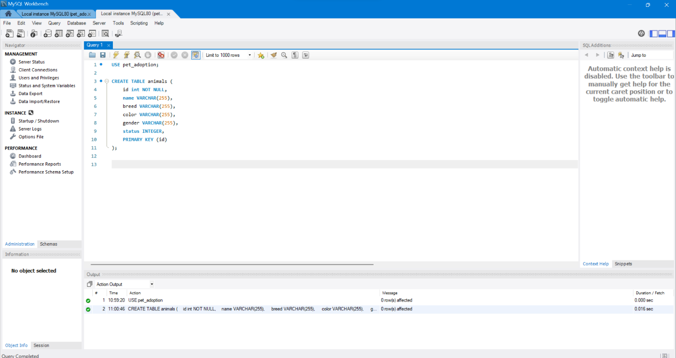

CREATE TABLE adoptions (animal_id UUID NOT NULL, name STRING, contact STRING, date TIMESTAMP);

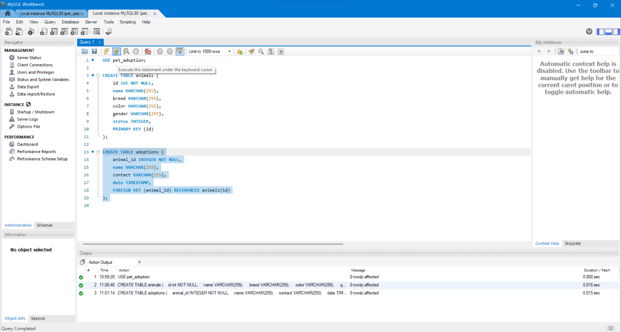

SHOW TABLES;

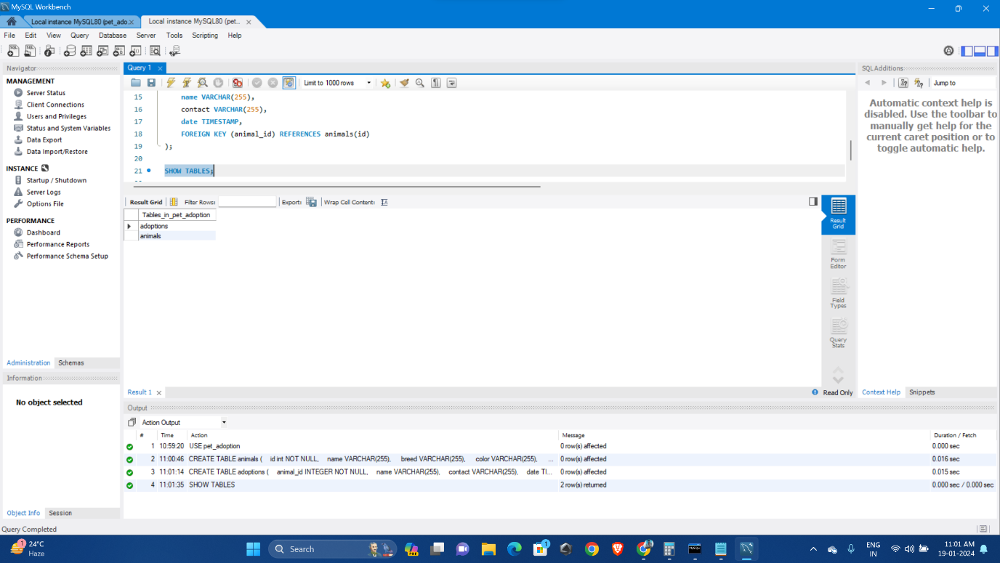

SHOW COLUMNS FROM animals;

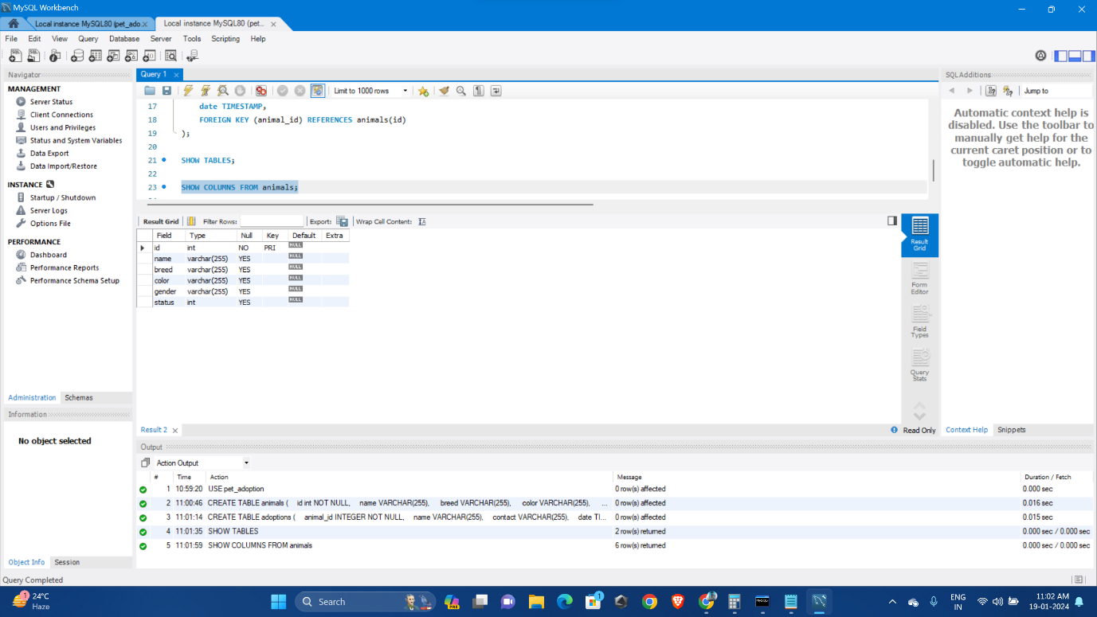

SHOW COLUMNS FROM adoptions;

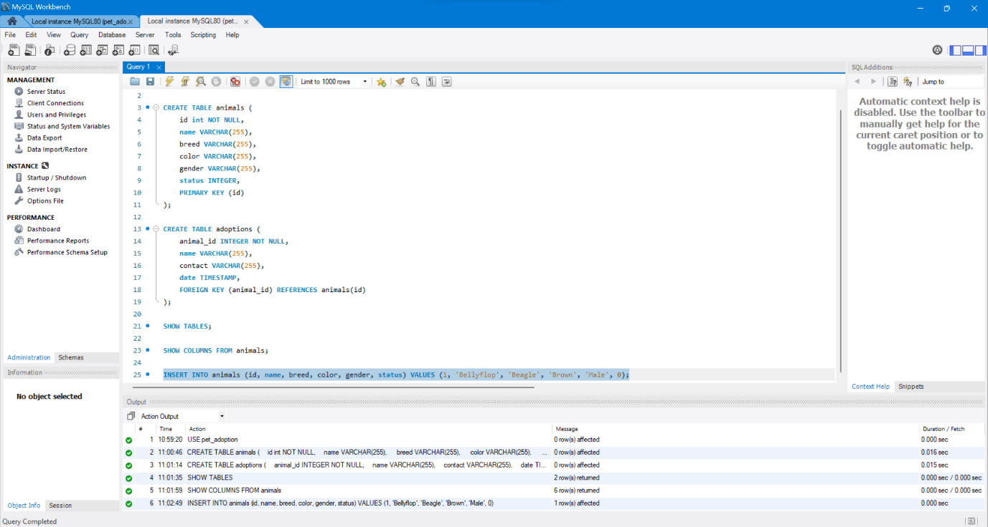

INSERT INTO animals (id, name, breed, color, gender, status) VALUES (1, 'Bellyflop', 'Beagle', 'Brown', 'Male', 0);

INSERT INTO animals (id, name, breed, color, gender, status) VALUES (2, 'Bellyflop', 'Beagle', 'Brown', 'Male', 0);

INSERT INTO animals (id, name, breed, color, gender, status) VALUES (3, 'Snowy', 'Husky', 'White', 'Female', 0);

INSERT INTO animals (id, name, breed, color, gender, status) VALUES (4, 'Princess', 'Pomeranian', 'Black', 'Female', 0);

INSERT INTO animals (id, name, breed, color, gender, status) VALUES (5, 'Cricket', 'Chihuahua', 'Brown', 'Male', 0);

INSERT INTO animals (id, name, breed, color, gender, status) VALUES (6, 'Princess', 'Poodle', 'Purple', 'Female', 0);

INSERT INTO animals (id, name, breed, color, gender, status) VALUES (7, 'Spot', 'Dalmation', 'Black and White', 'Male', 0); 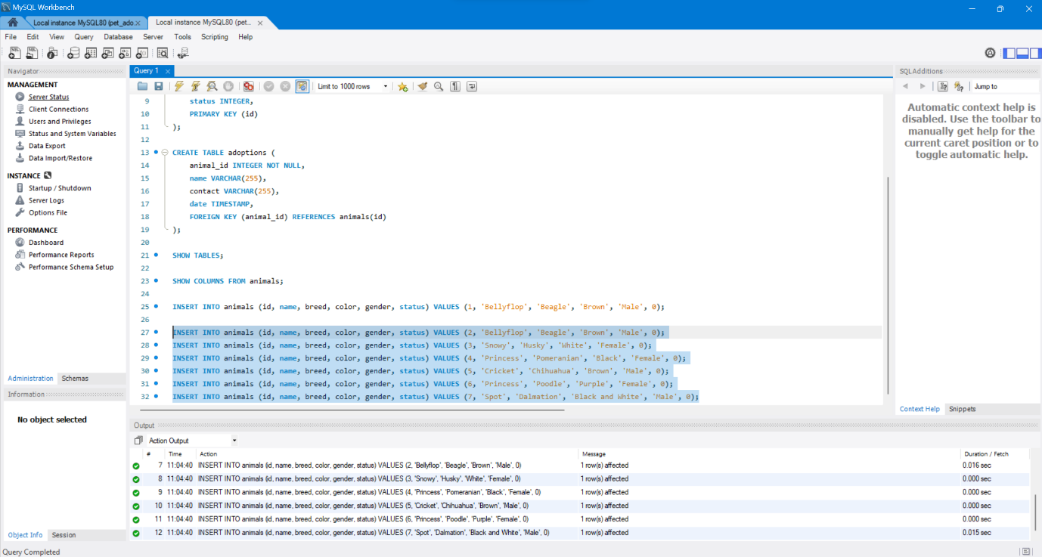

SELECT * FROM animals;

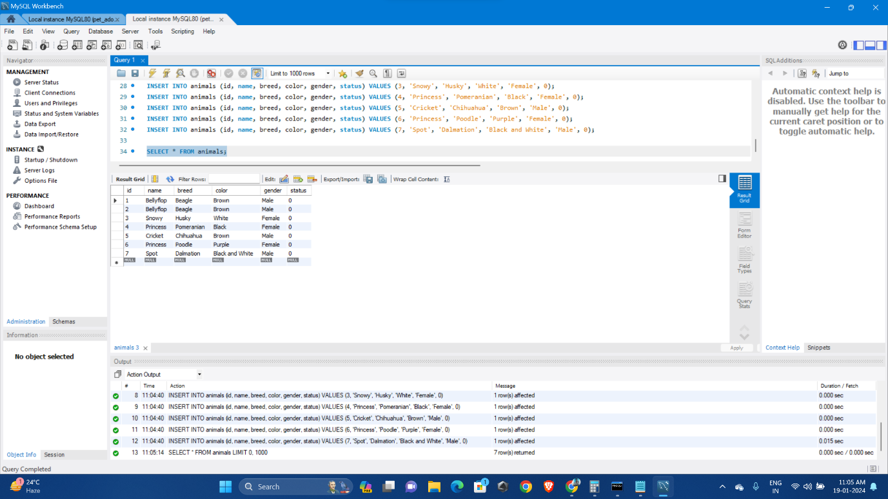

SELECT breed FROM animals;

SELECT name FROM animals WHERE gender = 'Female';

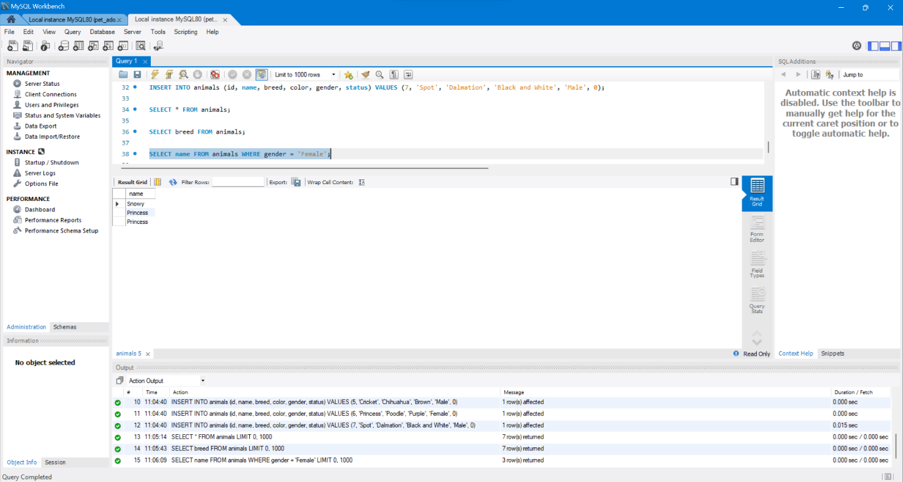

Get the IDs of dogs up for adoption:

SELECT id FROM animals WHERE status = 0;

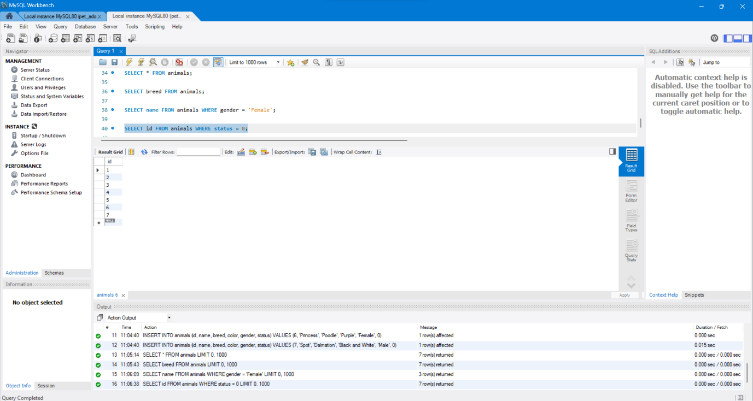

UPDATE animals SET color = 'Brown' WHERE id = 2;

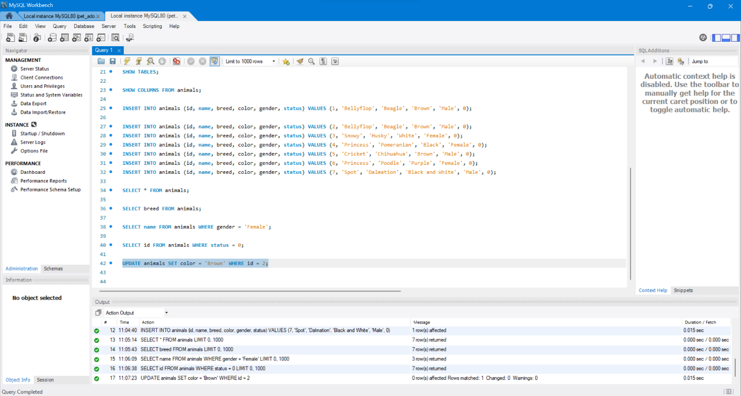

UPDATE animals SET color = 'Brown' WHERE name = 'Princess';

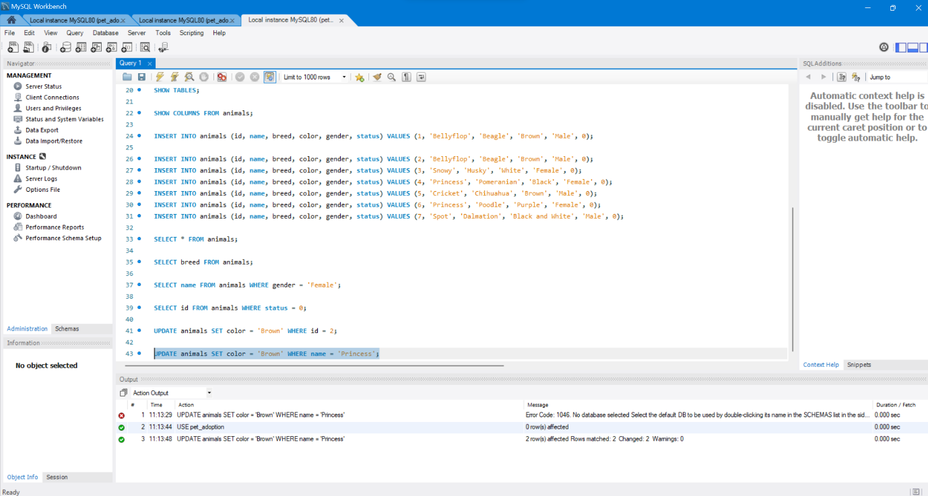

UPDATE animals SET color = 'Brown' WHERE color = 'Purple';

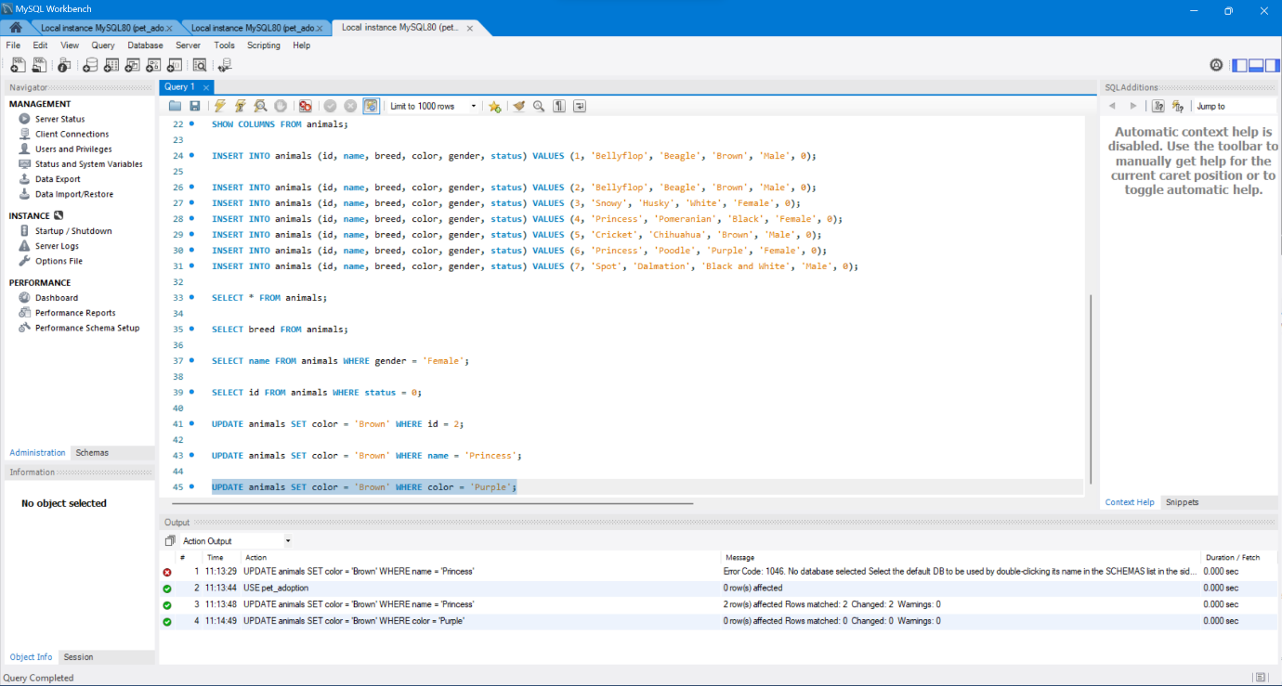

UPDATE animals SET status = 1 WHERE id = 2;

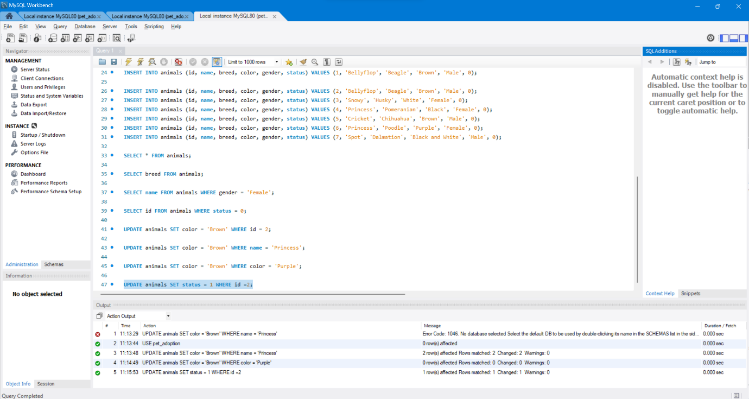

INSERT INTO adoptions (animal_id, name, contact, date) VALUES (1, 'Pinocchio', 'realboy@cockroachlabs.com', NOW());

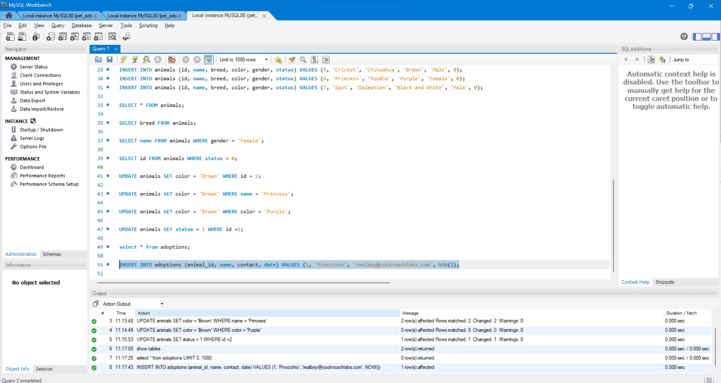

UPDATE animals SET status = 1 WHERE id = 2';

INSERT INTO adoptions (animal_id, name, contact, date) VALUES (2, 'Patalie', 'poodlequeen@cockroachlabs.com', NOW());

UPDATE animals SET status = 1 WHERE id = 3;

INSERT INTO adoptions (animal_id, name, contact, date) VALUES (3, 'Ella', 'ellacrew@cockroachlabs.com', NOW());

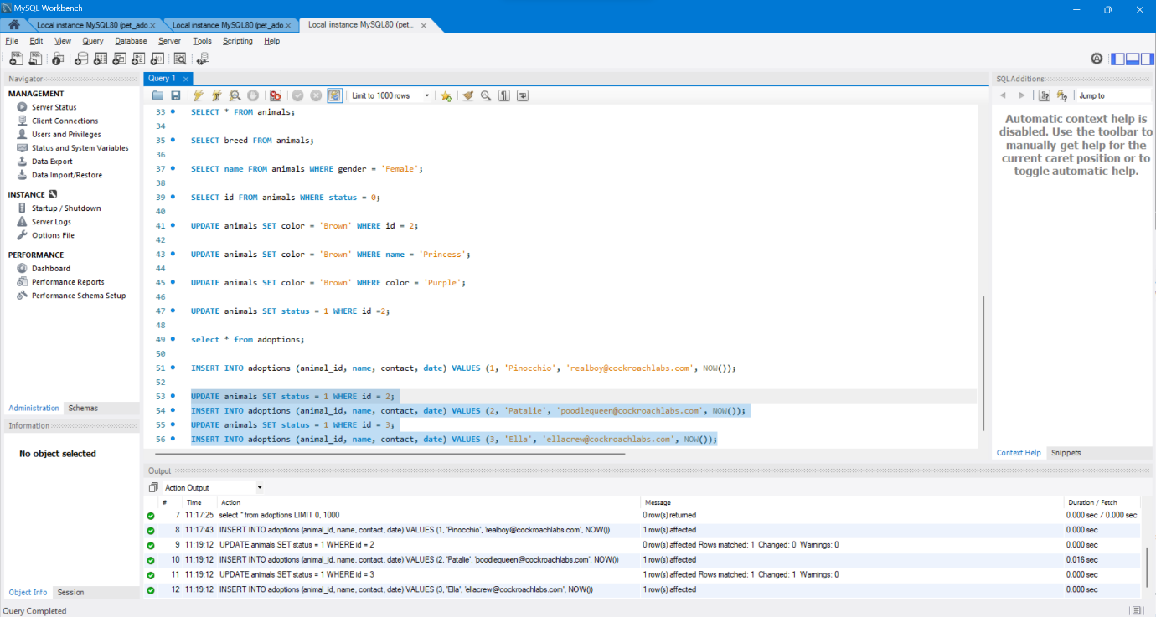

SELECT * FROM adoptions;

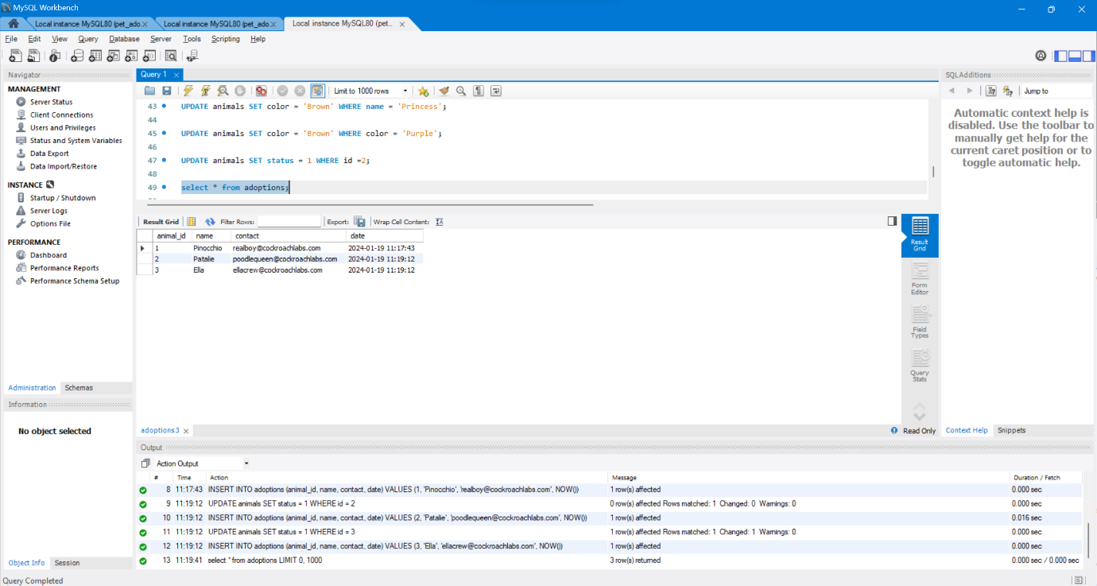

SELECT * FROM adoptions ORDER BY date DESC;

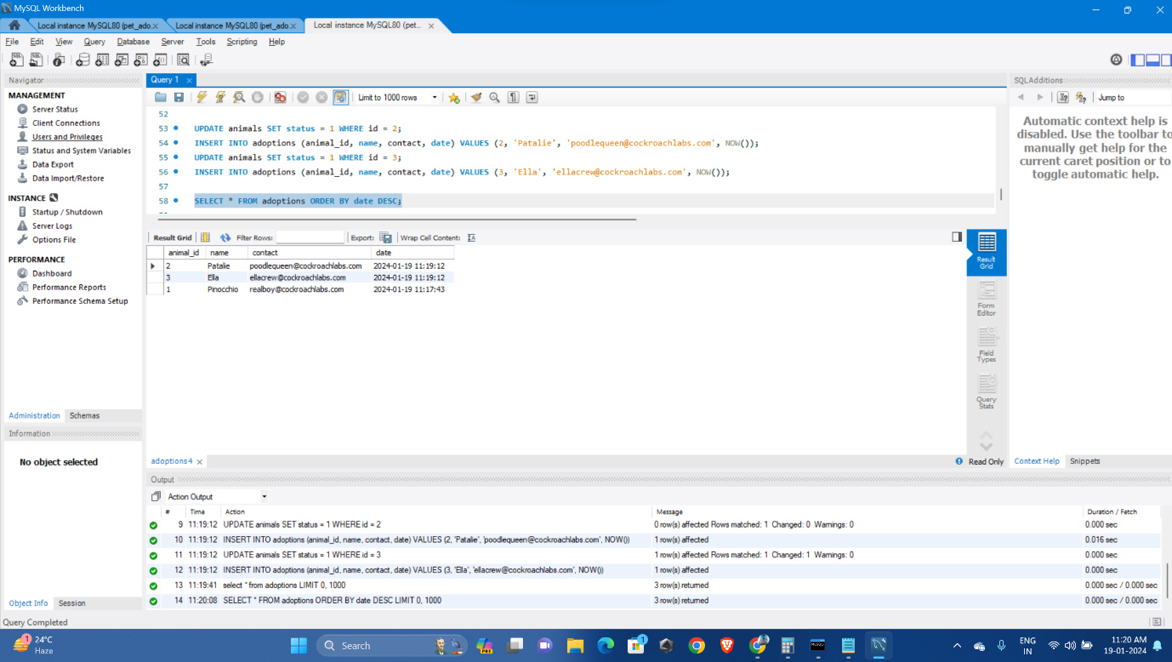

SELECT * FROM animals WHERE status = 1;

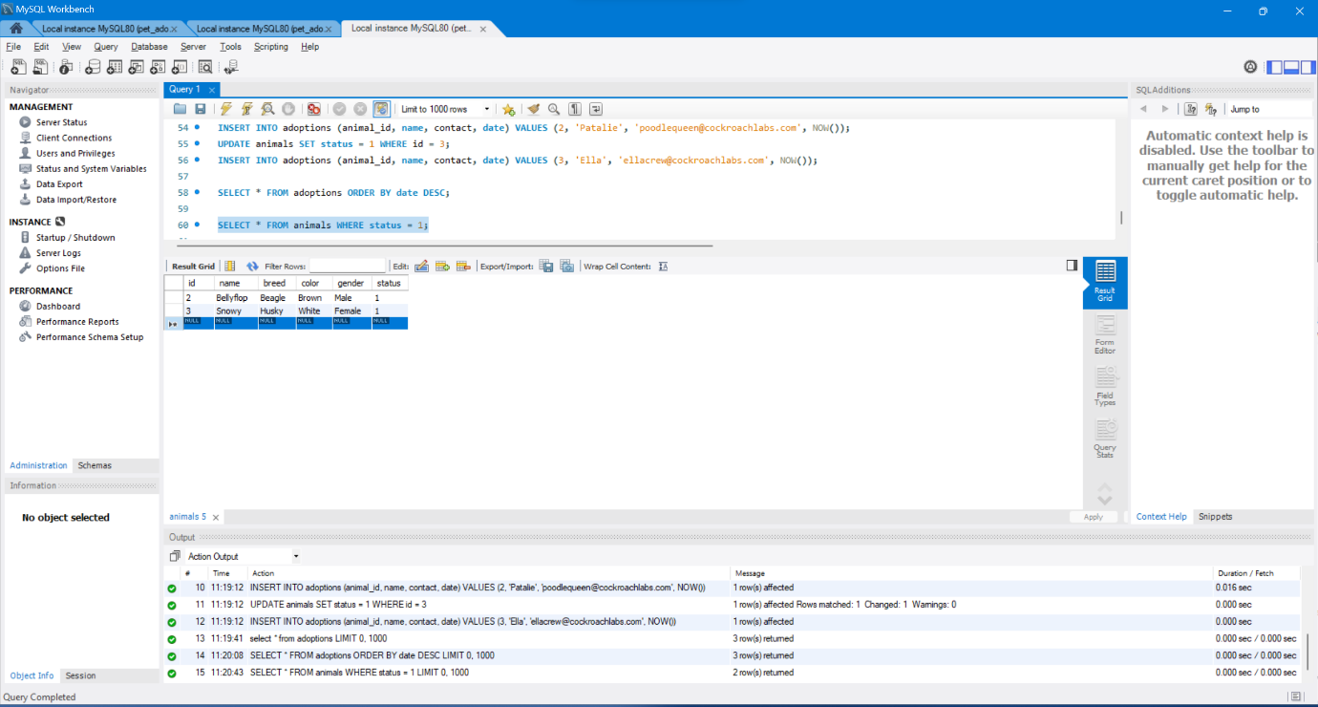

ALTER TABLE animals ADD COLUMN species VARCHAR(255);

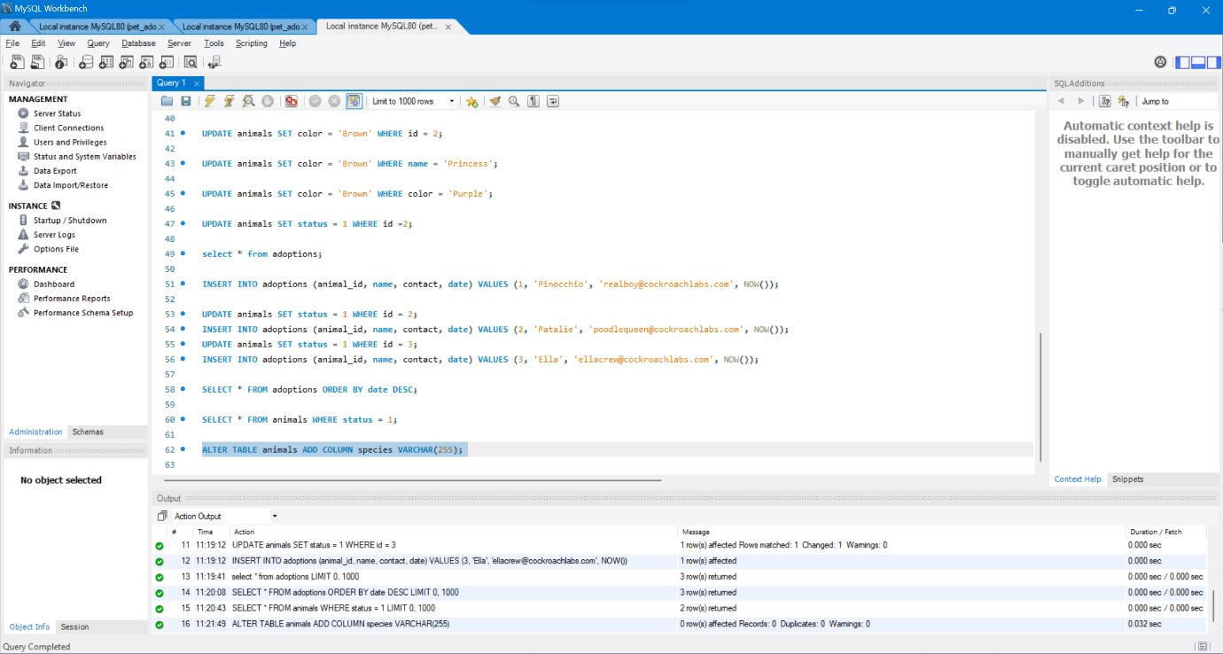

SHOW COLUMNS FROM animals;

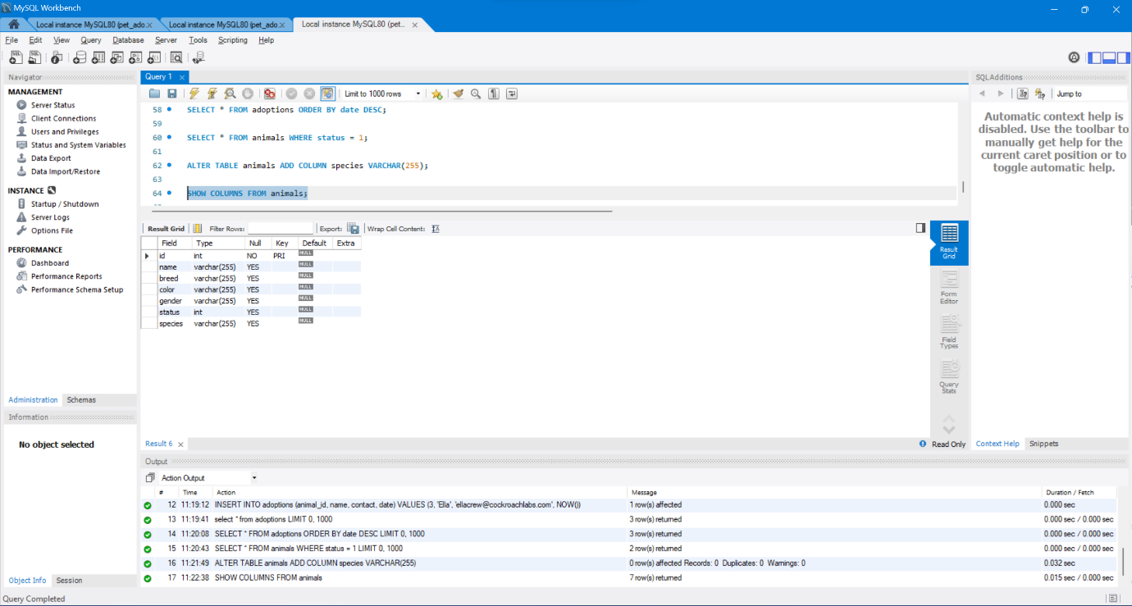

UPDATE animals SET species = 'Dog';

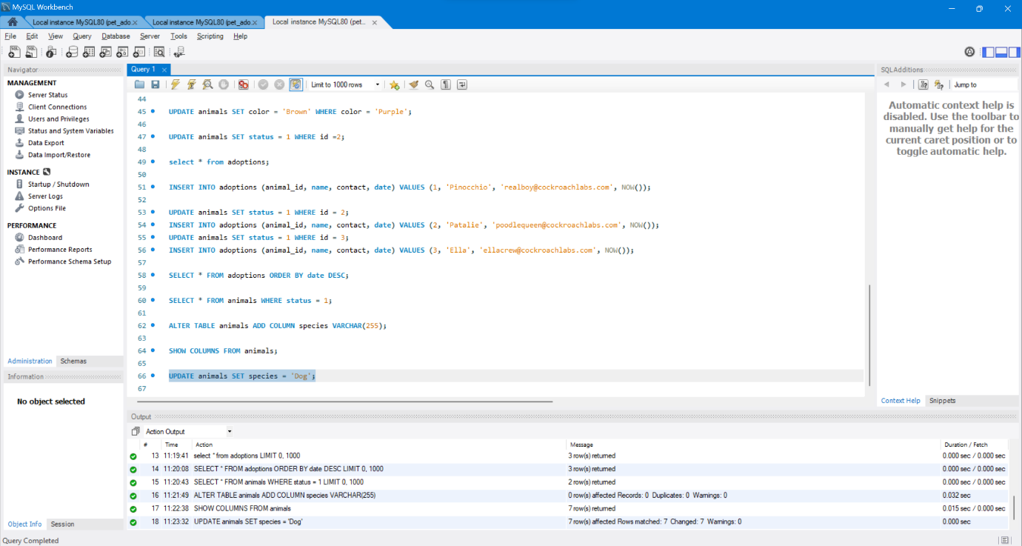

INSERT INTO animals (id, name, species, breed, color, gender, status) VALUES 8, 'Meowmix', 'Cat', 'Munchkin', 'Yellow', 'Female', 0);

INSERT INTO animals (id, name, species, breed, color, gender, status) VALUES (9, 'Ash', 'Cat', 'Persian', 'Gray', 'Female', 0);

INSERT INTO animals (id, name, species, breed, color, gender, status) VALUES (10, 'Tiger', 'Cat', 'Bengal', 'Brown', 'Male', 0);

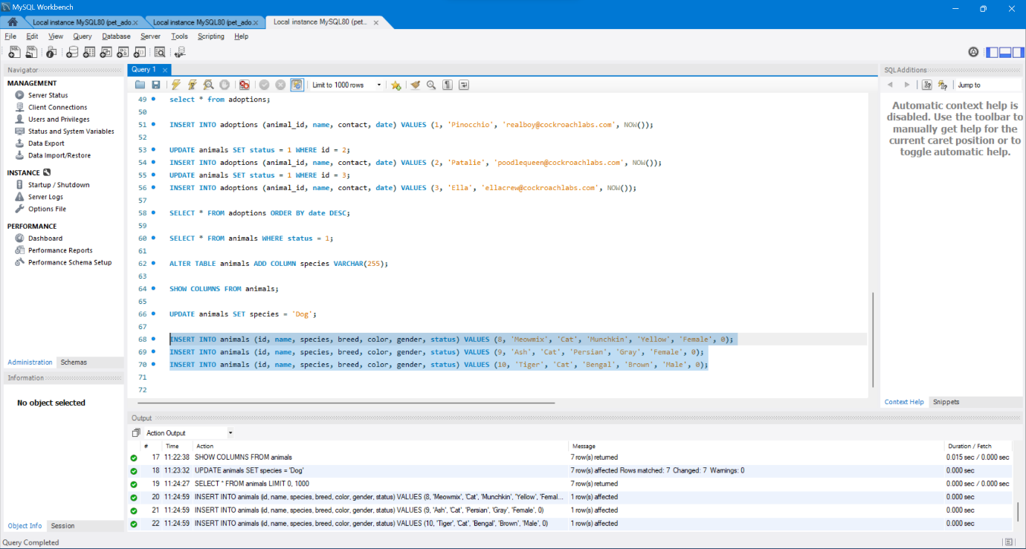

SELECT * FROM animals;

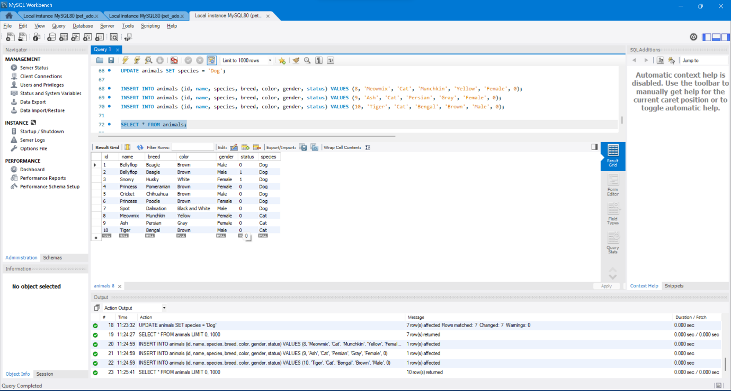

CREATE TABLE shelters (id INTEGER, name STRING, location STRING);

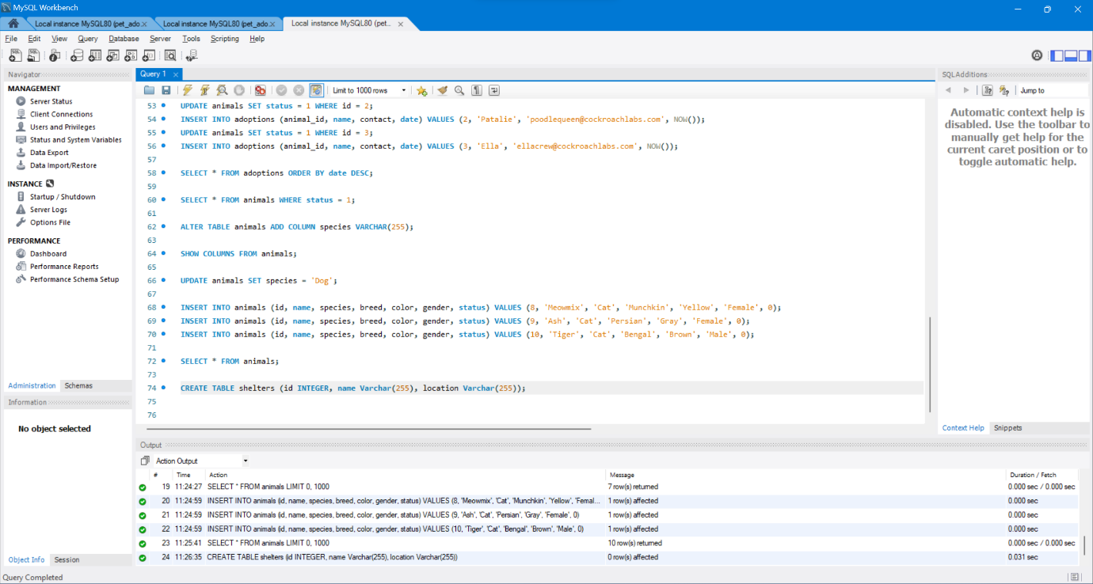

INSERT INTO shelters (id, name, location) VALUES (1, 'Animals 4 Homes', 'Red City');

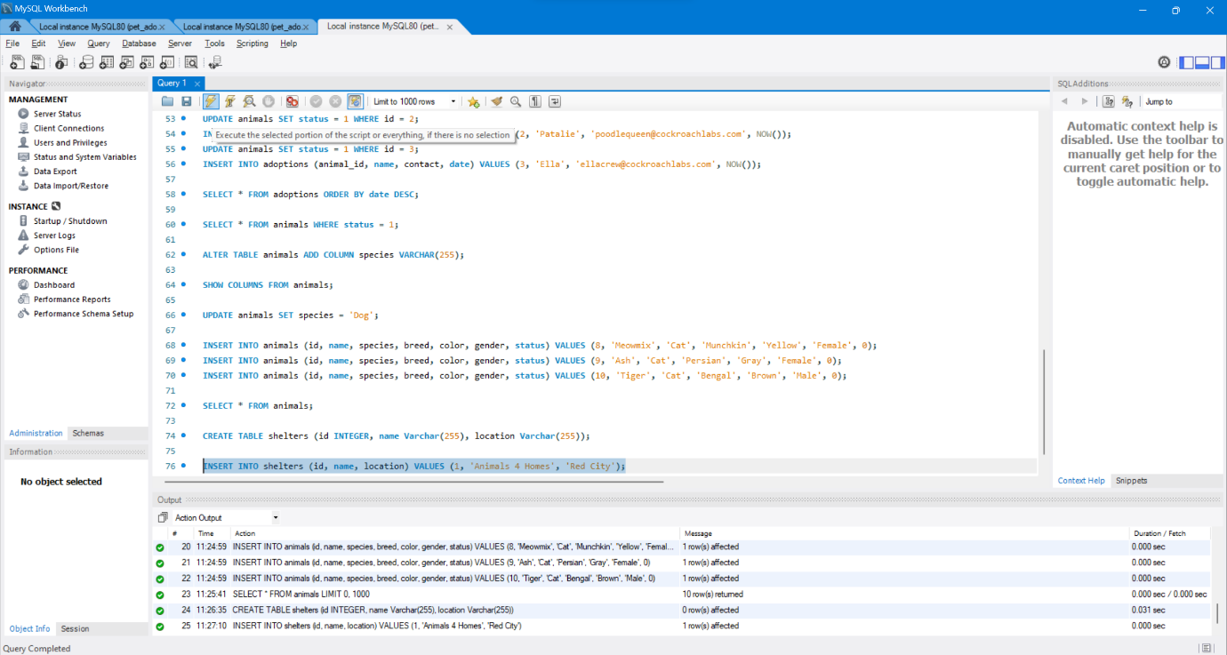

ALTER TABLE animals ADD COLUMN shelter INTEGER;

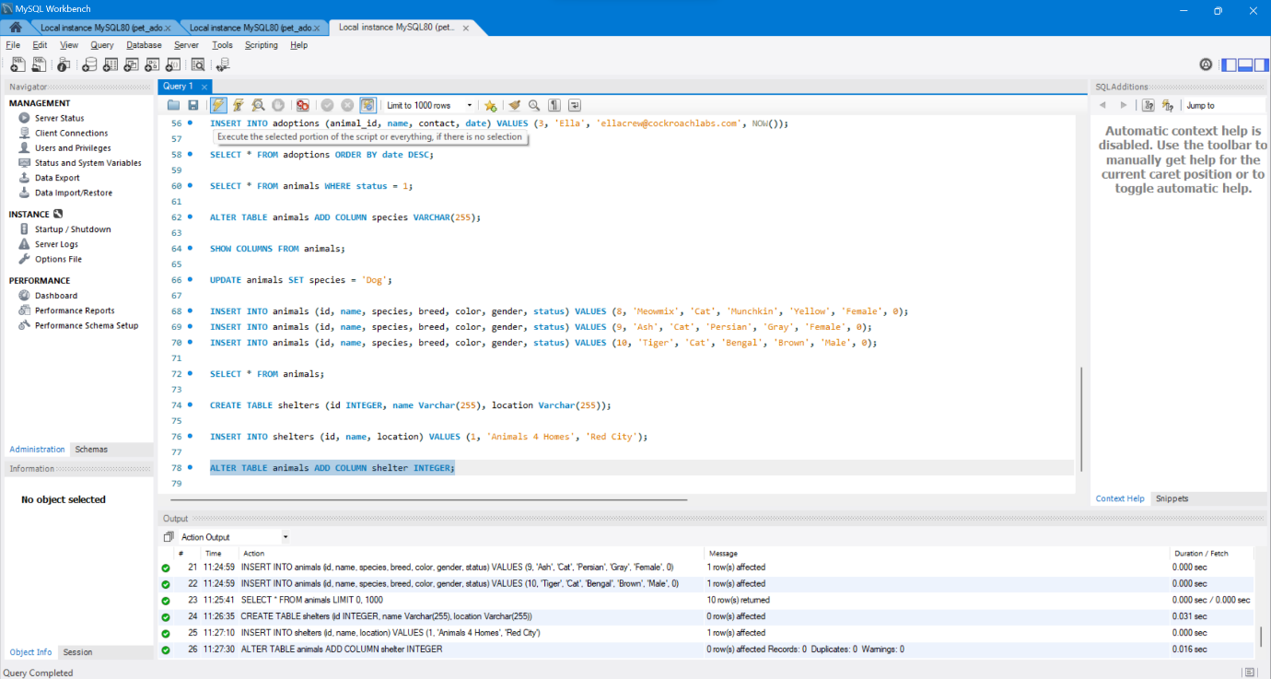

UPDATE animals SET shelter = 1;

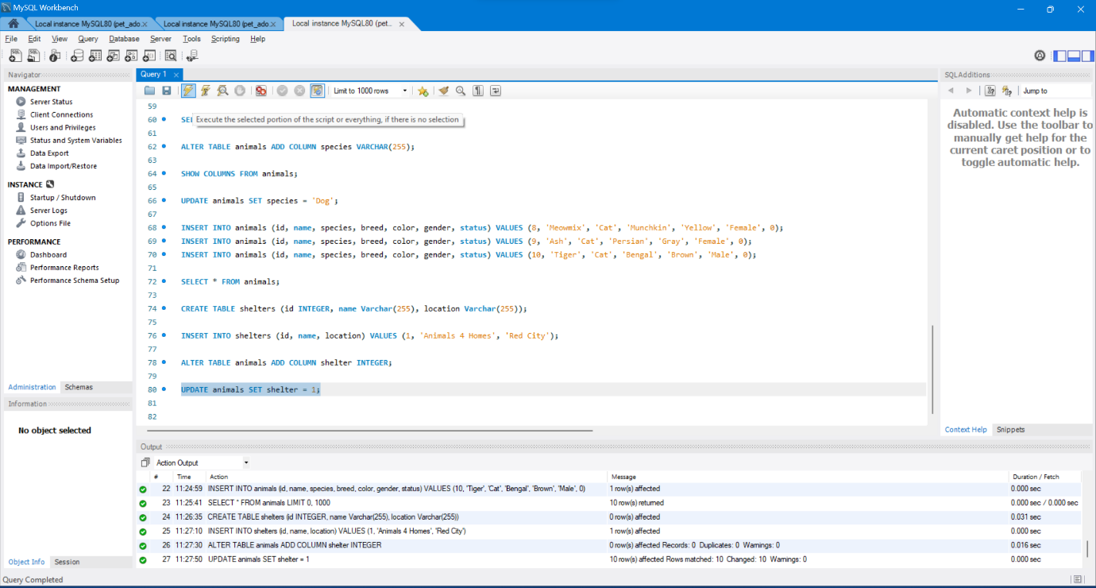

INSERT INTO shelters (id, name, location) VALUES (2, 'Adopt A Buddy', 'Green Town');

INSERT INTO shelters (id, name, location) VALUES (3, 'Fluffy Animals', 'Blue Hills');

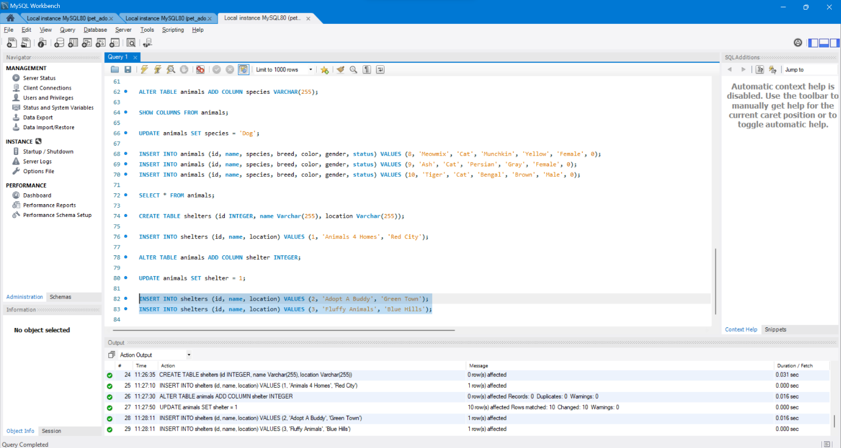

INSERT INTO animals (id, name, shelter, species, breed, color, gender, status) VALUES (11, 'Snoops', 2, 'Dog', 'Beagle', 'Brown', 'Male', 0);

INSERT INTO animals (id, name, shelter, species, breed, color, gender, status) VALUES (12, 'Salt', 2, 'Cat', 'Turkish Angora', 'White', 'Female', 0);

INSERT INTO animals (id, name, shelter, species, breed, color, gender, status) VALUES (13, 'Fuzz', 3, 'Dog', 'Papillon', 'Gray', 'Male', 0);

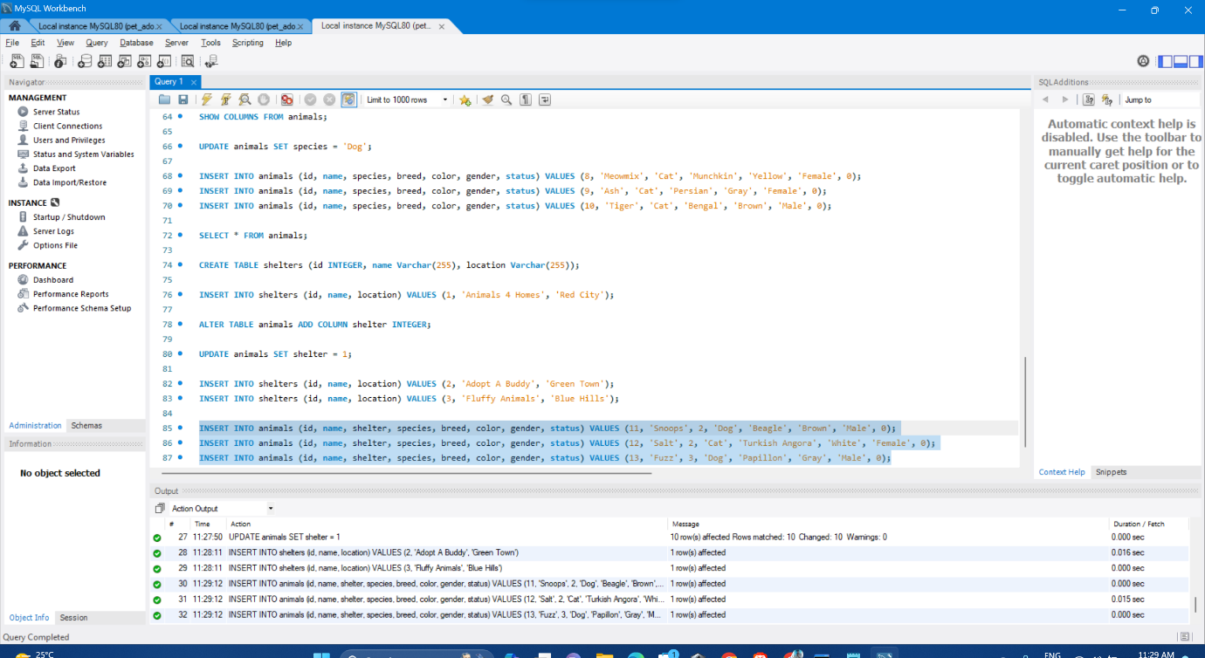

**More Advanced SQL: Indexes and Joins**

SELECT * FROM adoptions JOIN animals ON adoptions.animal_id = animals.id WHERE animals.shelter = 1;

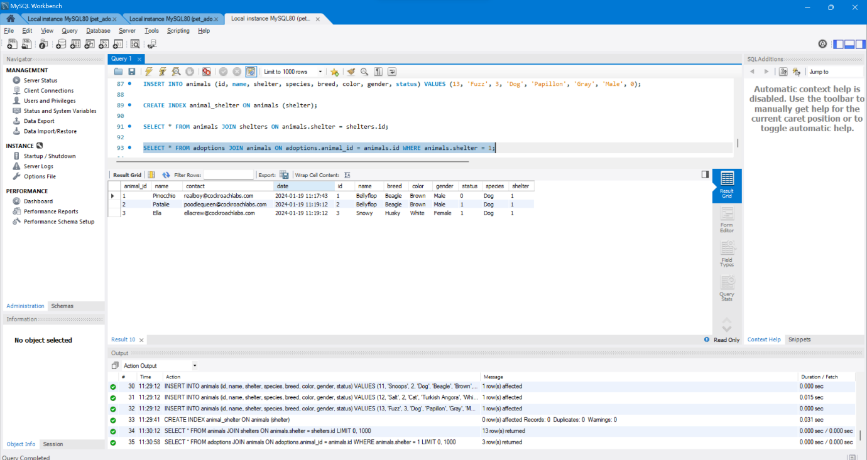

**SQL_D**

SELECT * FROM Customers;

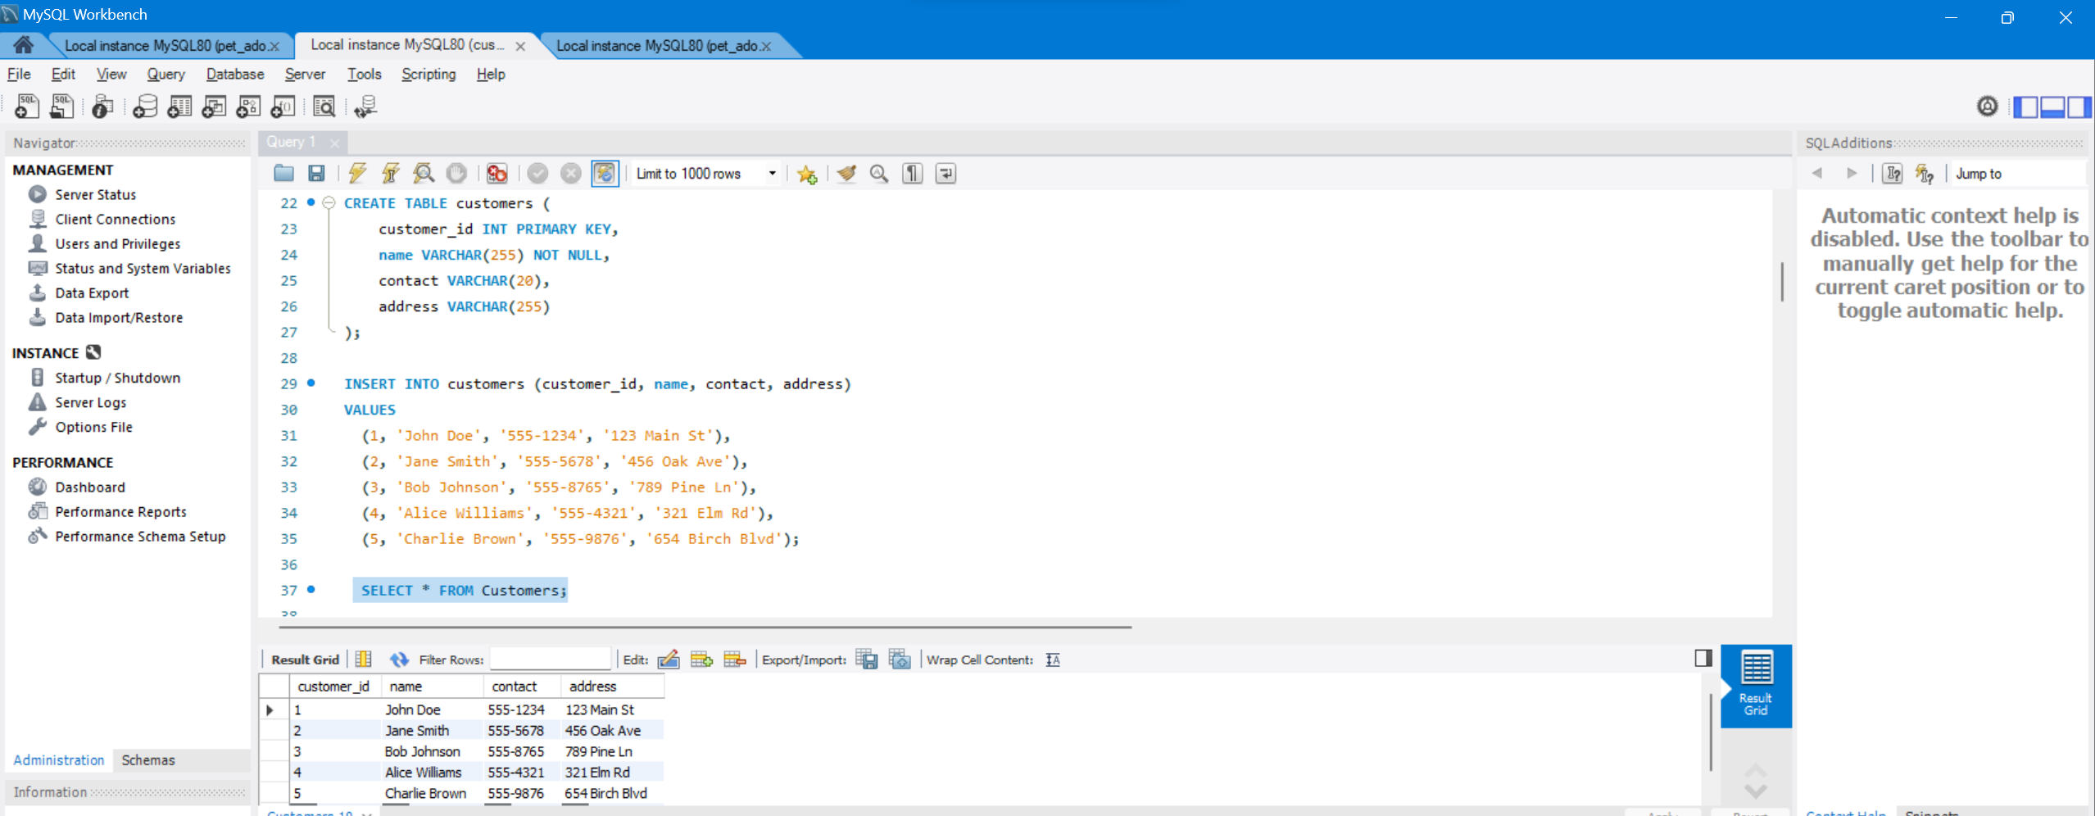

SELECT DISTINCT Names FROM Customers;

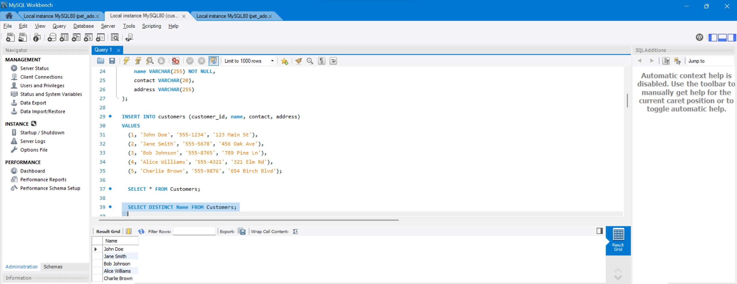

### Having Clause :

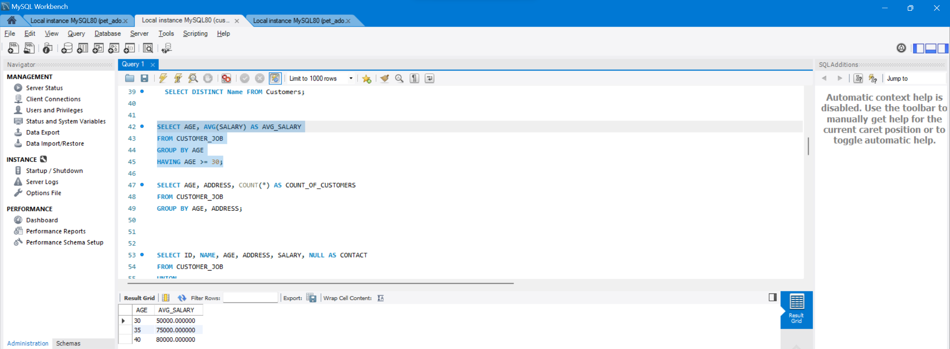

### Group By Clause :

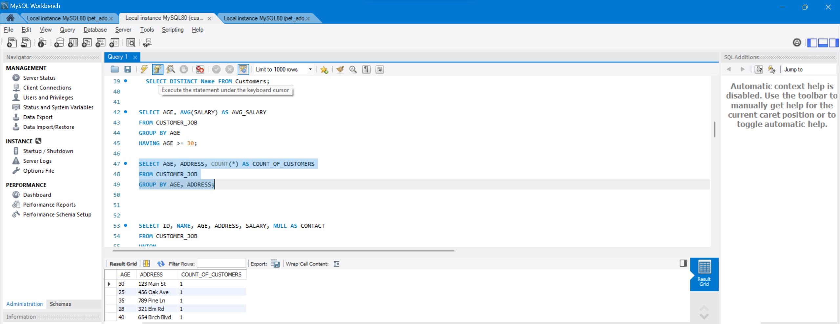

**Table 1: t_employees**

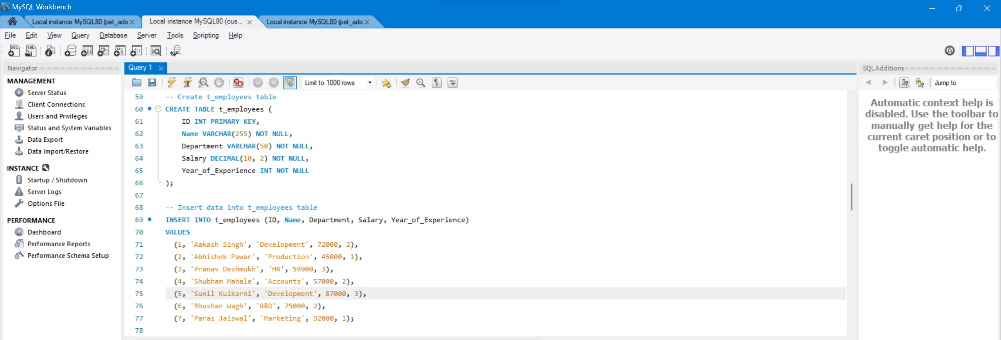

**Table 2: t2_employees**

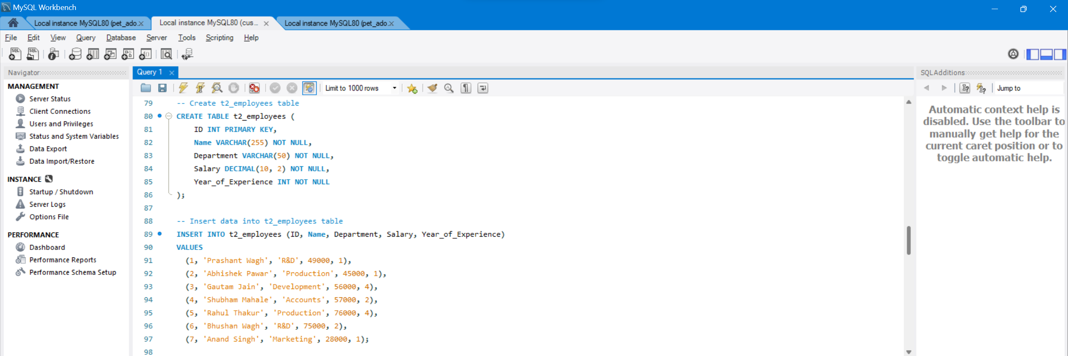

**Table 3: t_students**

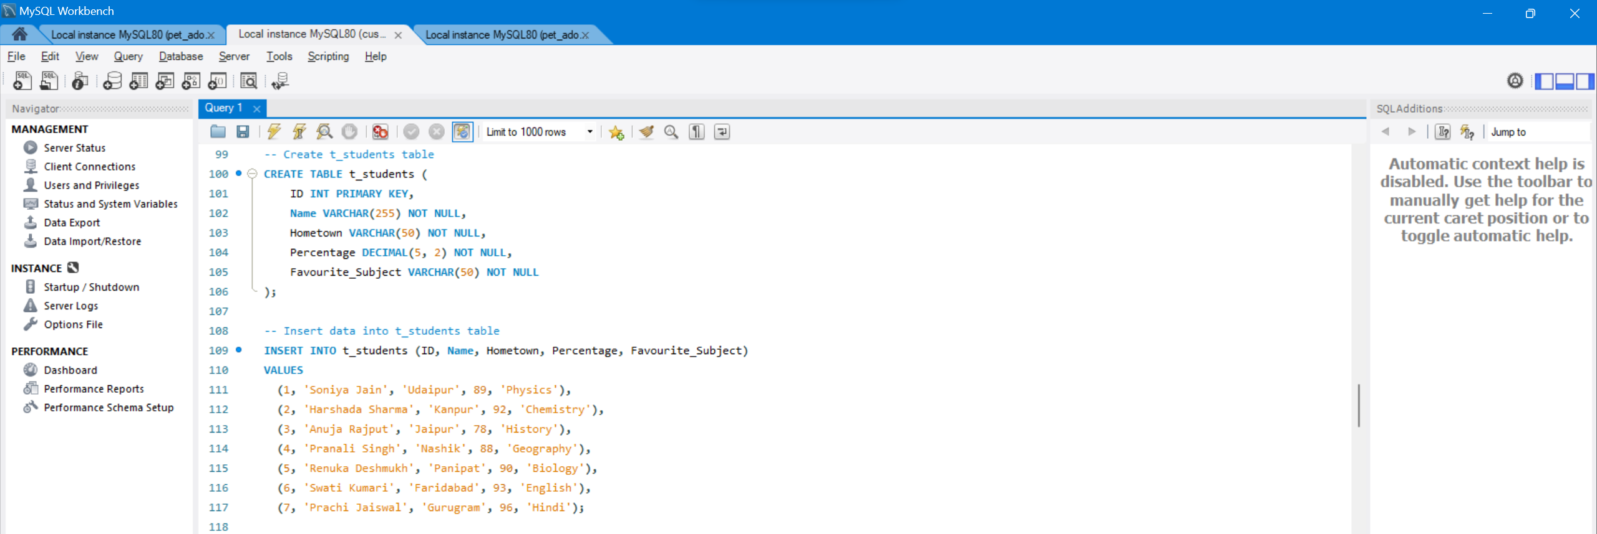

**Table 4: t2_students**

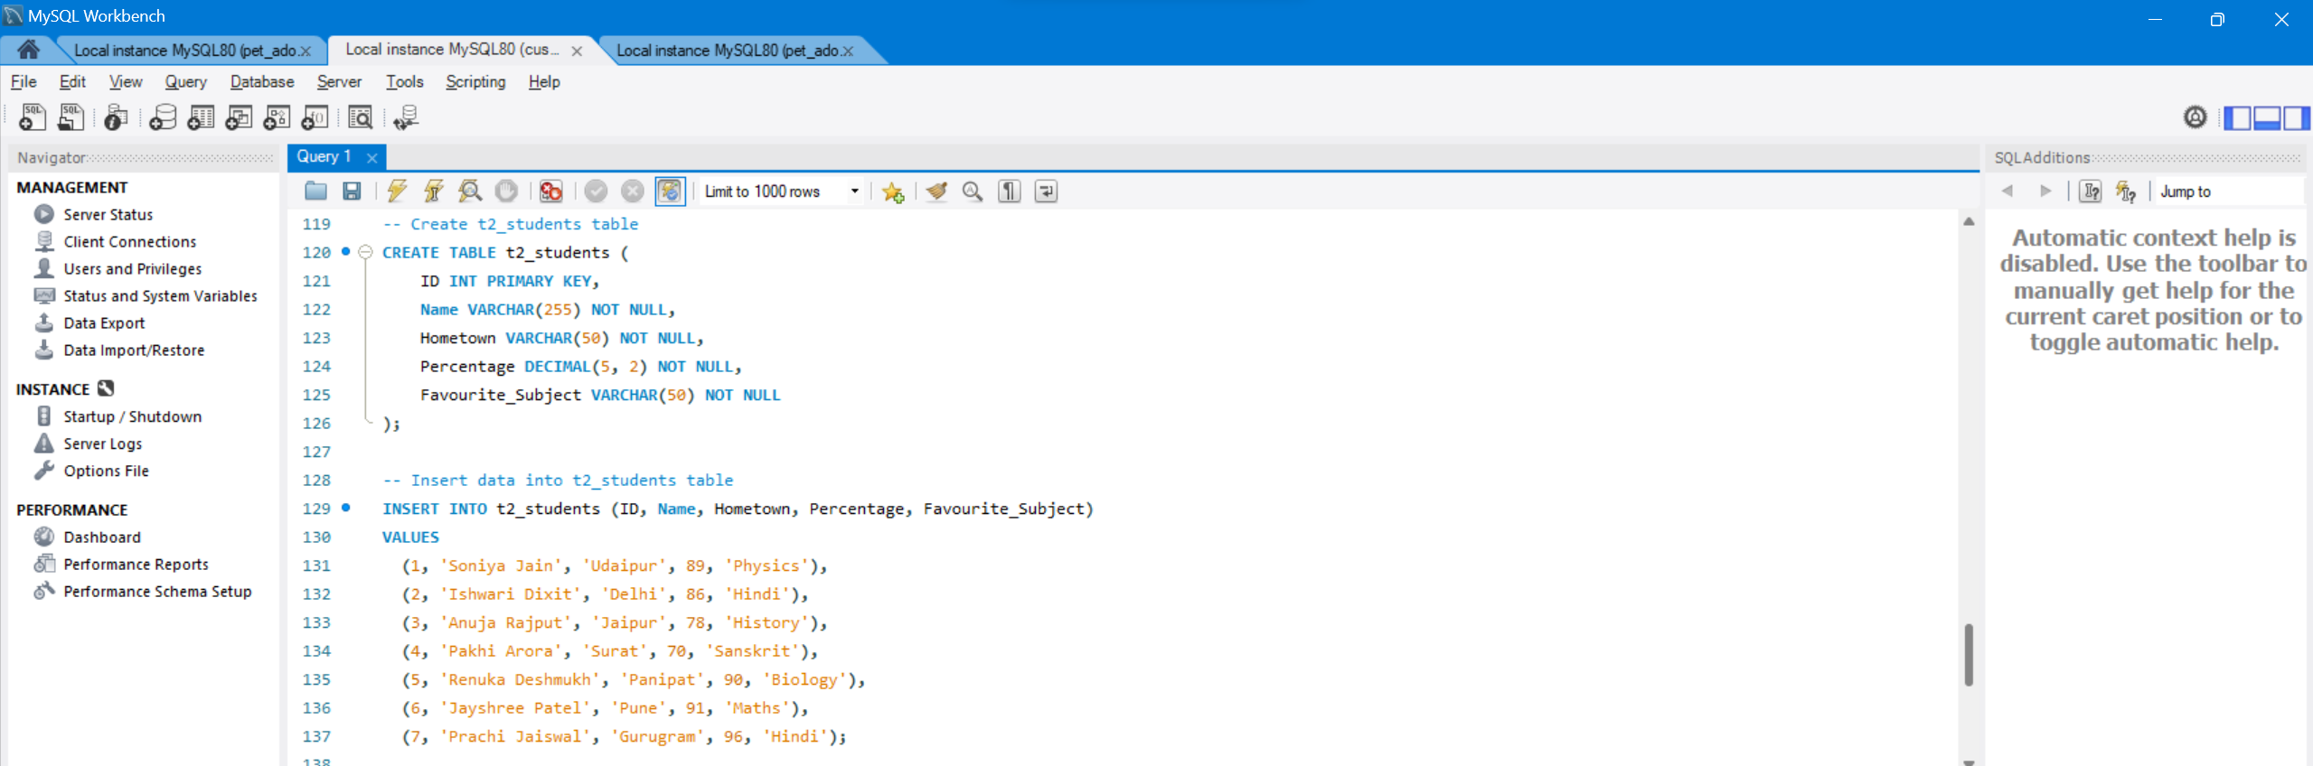

1. mysql> **SELECT** \***FROM** t_employees **UNION** **SELECT** \***FROM** t2_employees;

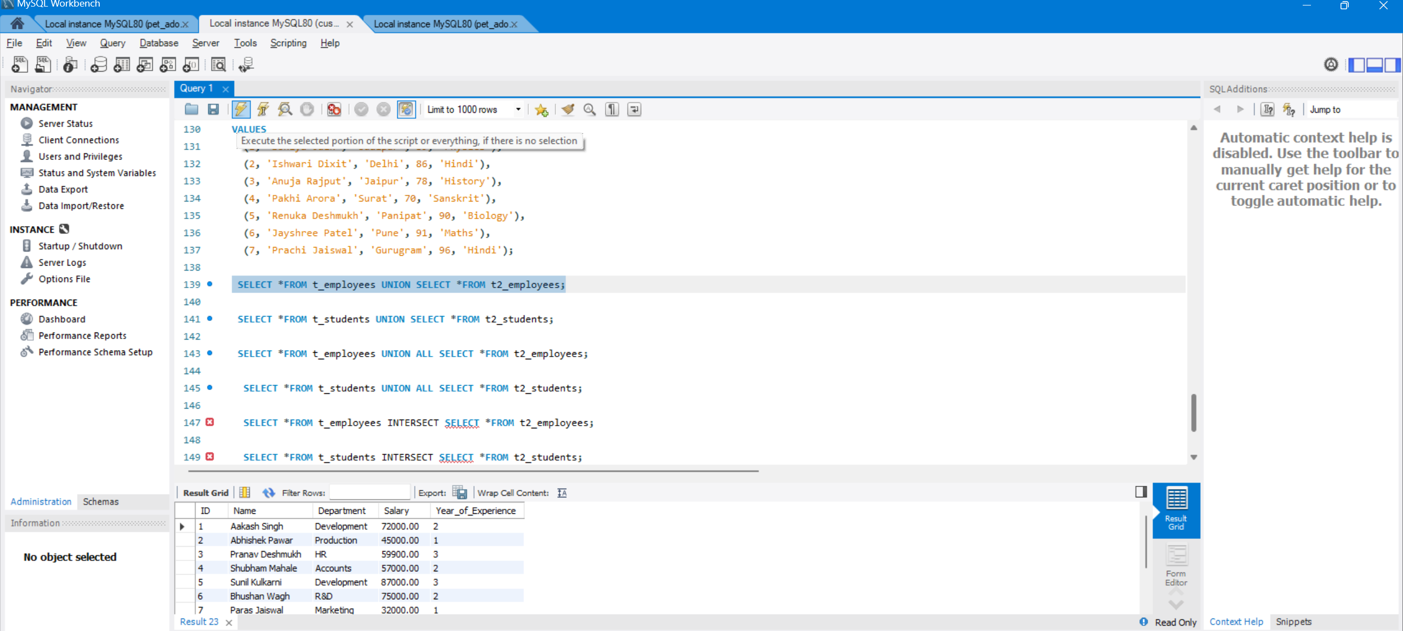

**Example 2:**

1. mysql> **SELECT** \***FROM** t_students **UNION** **SELECT** \***FROM** t2_students;

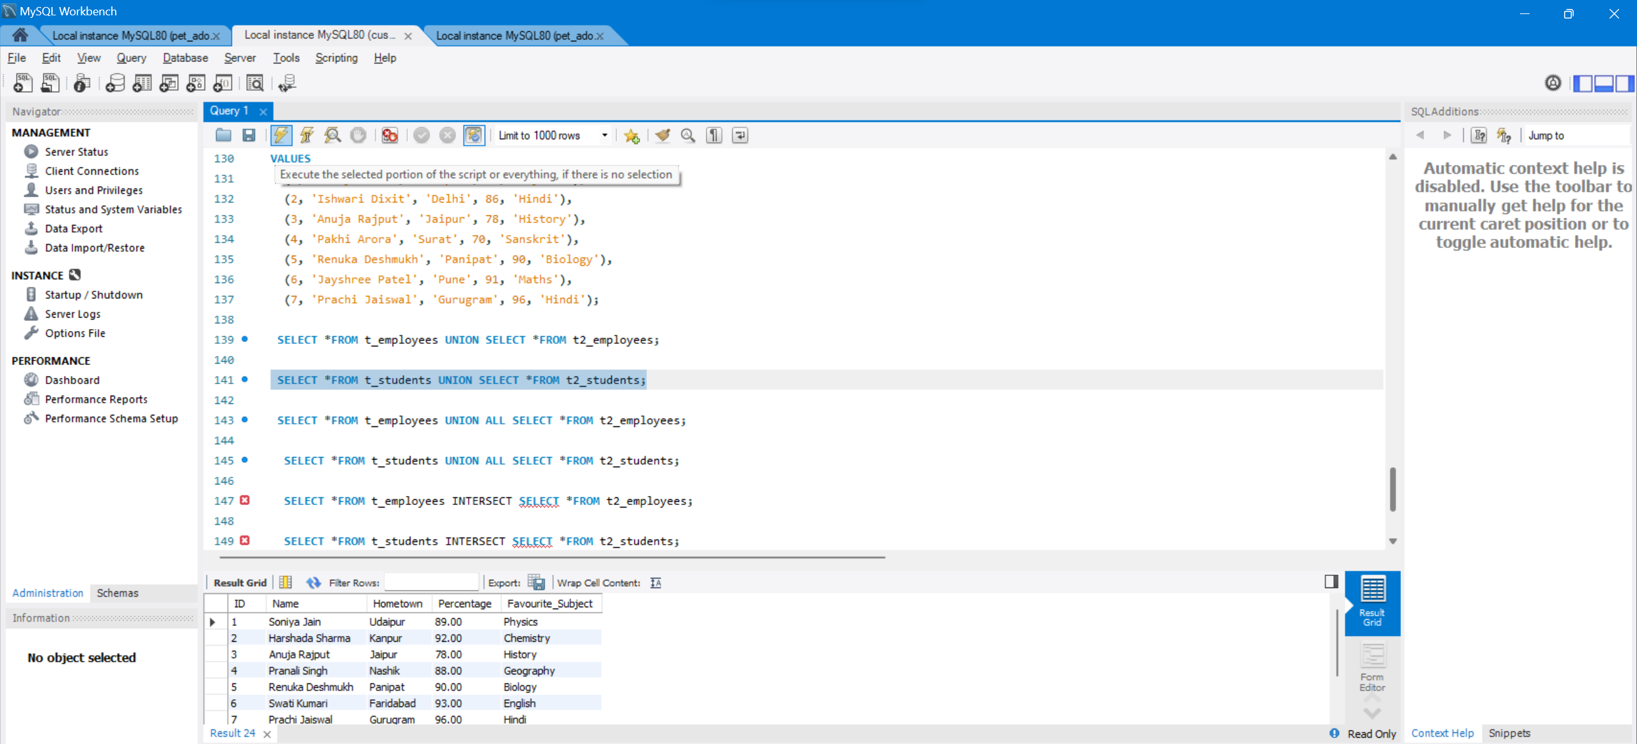

**Query:**

1. mysql> **SELECT** \***FROM** t_employees **UNION** ALL **SELECT** \***FROM** t2_employees;

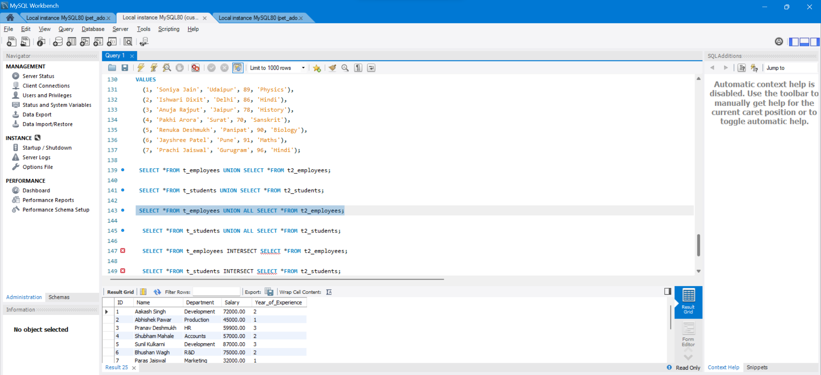

**Example 2:**

1. mysql> **SELECT** \***FROM** t_students **UNION** ALL **SELECT** \***FROM** t2_students;

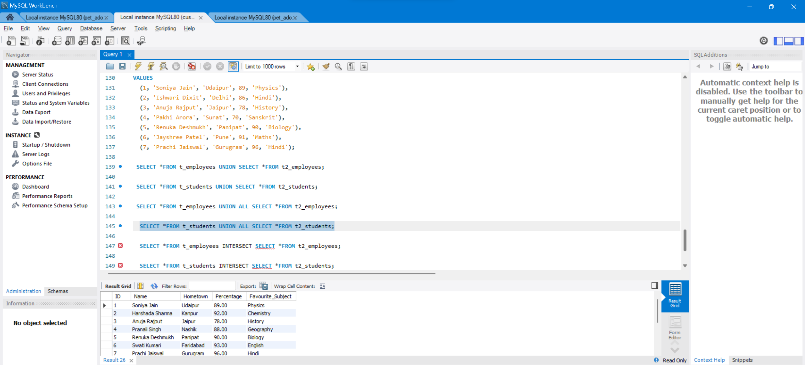

1. mysql> **SELECT** \***FROM** t_employees **INTERSECT** **SELECT** \***FROM** t2_employees;

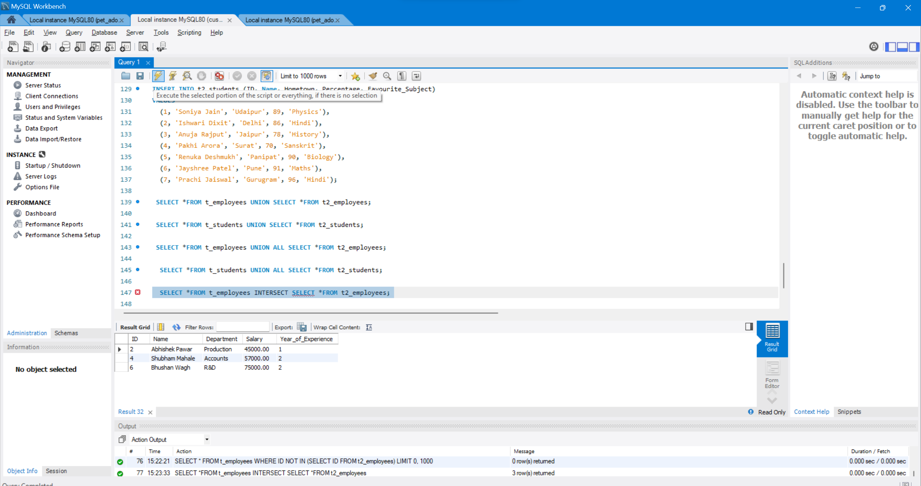

1. mysql> **SELECT** \***FROM** t_employees MINUS **SELECT** \***FROM** t2_employees;

**Operators**

CREATE DATABASE xstream_db;

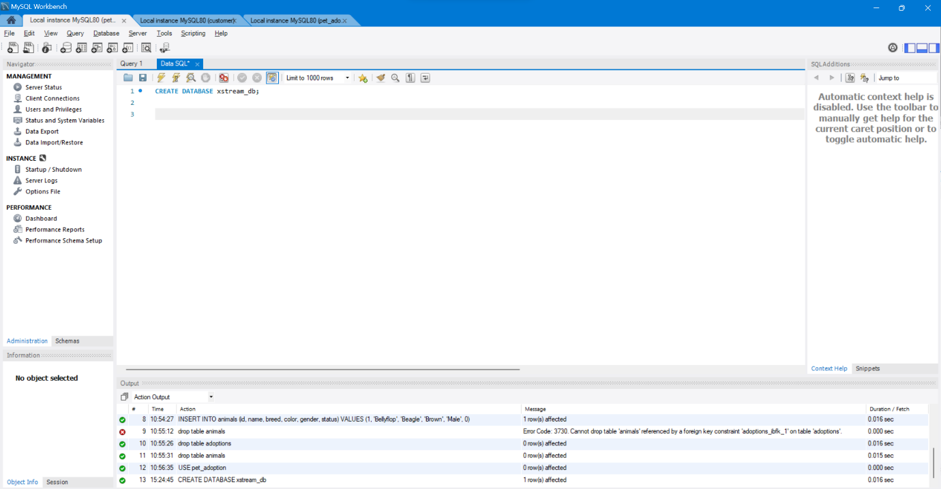

**Step 2:**Create table employee

### **Query**

CREATE TABLE employee (emp_id INT, emp_name VARCHAR(255),

emp_city VARCHAR(255),

emp_country VARCHAR(255),

PRIMARY KEY (emp_id));

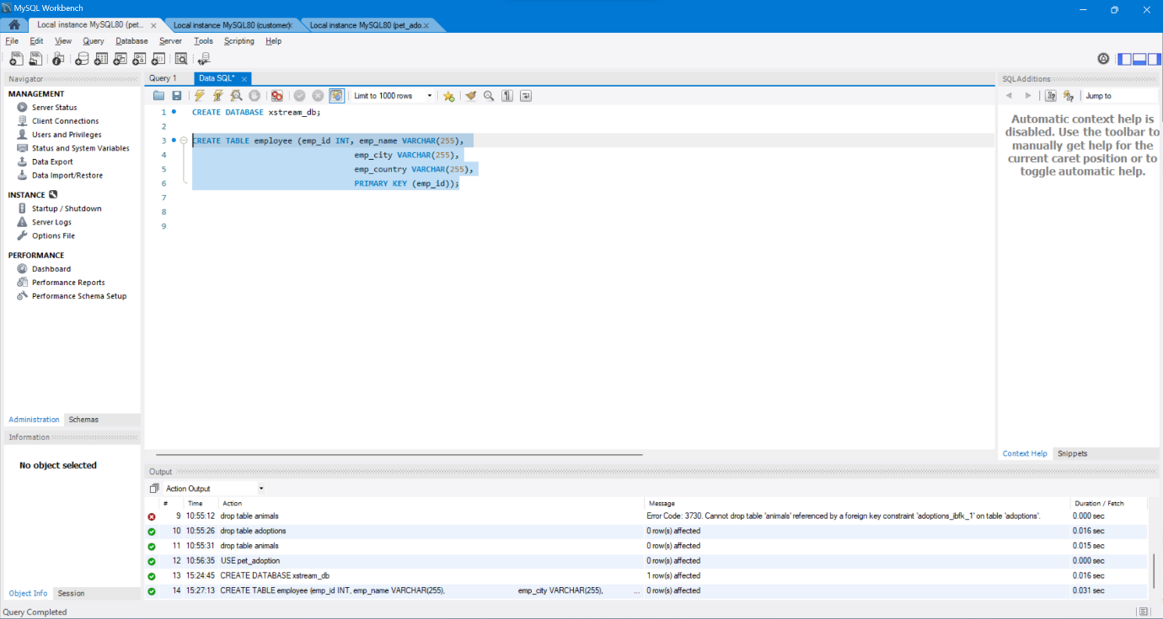

*Create Table*

### **Query**

INSERT INTO employee VALUES (101, 'Utkarsh Tripathi', 'Varanasi', 'India'),

(102, 'Abhinav Singh', 'Varanasi', 'India'),

(103, 'Utkarsh Raghuvanshi', 'Varanasi', 'India'),

(104, 'Utkarsh Singh', 'Allahabad', 'India'),

(105, 'Sudhanshu Yadav', 'Allahabad', 'India'),

(106, 'Ashutosh Kumar', 'Patna', 'India');

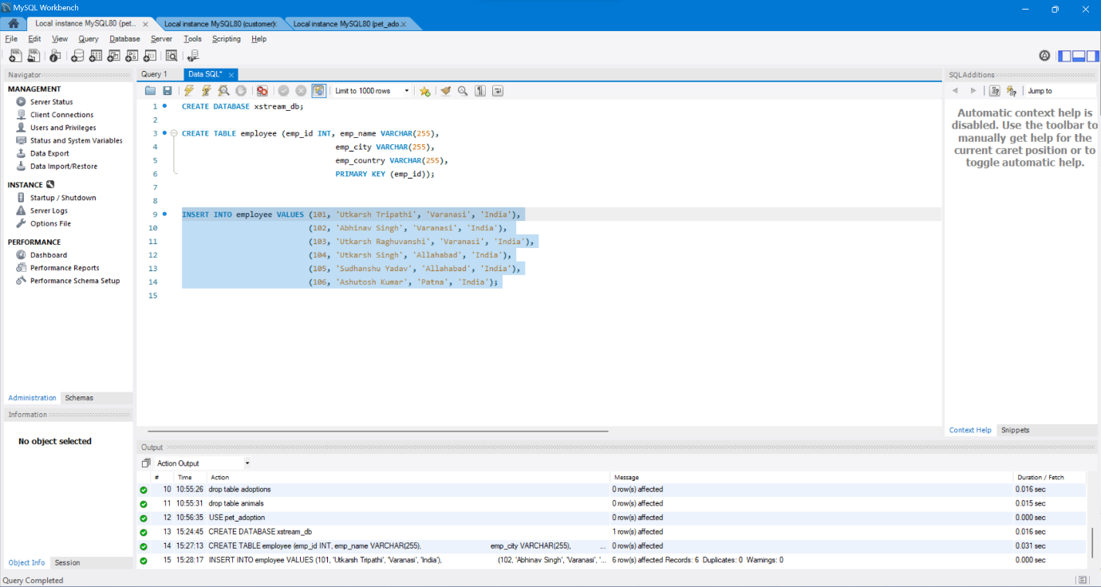

## **AND Operator**

### **Query**

SELECT * FROM employee WHERE emp_city = 'Allahabad' AND emp_country = 'India';

### **Output**

### 

## **IN Operator**

### **Query**

SELECT * FROM employee WHERE emp_city IN ('Allahabad', 'Patna');

### **Output**

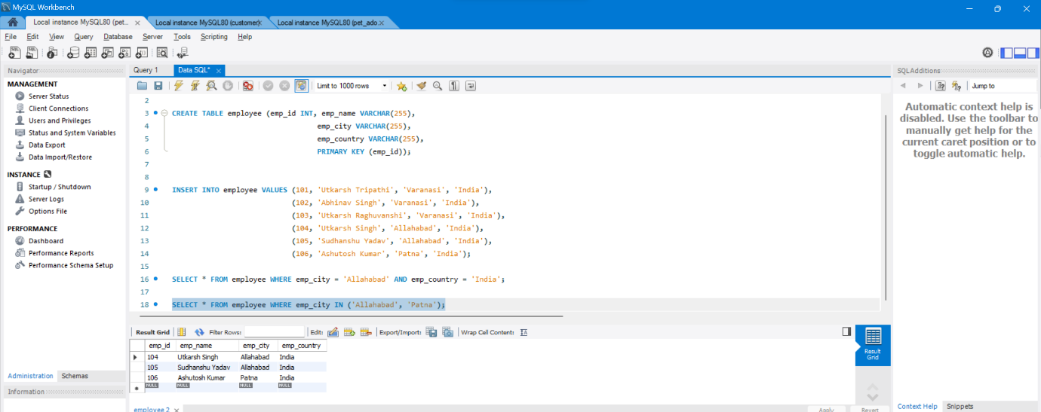

*output*

## **NOT Operator**

### **Query**

SELECT * FROM employee WHERE emp_city NOT LIKE 'A%';

### **Output**

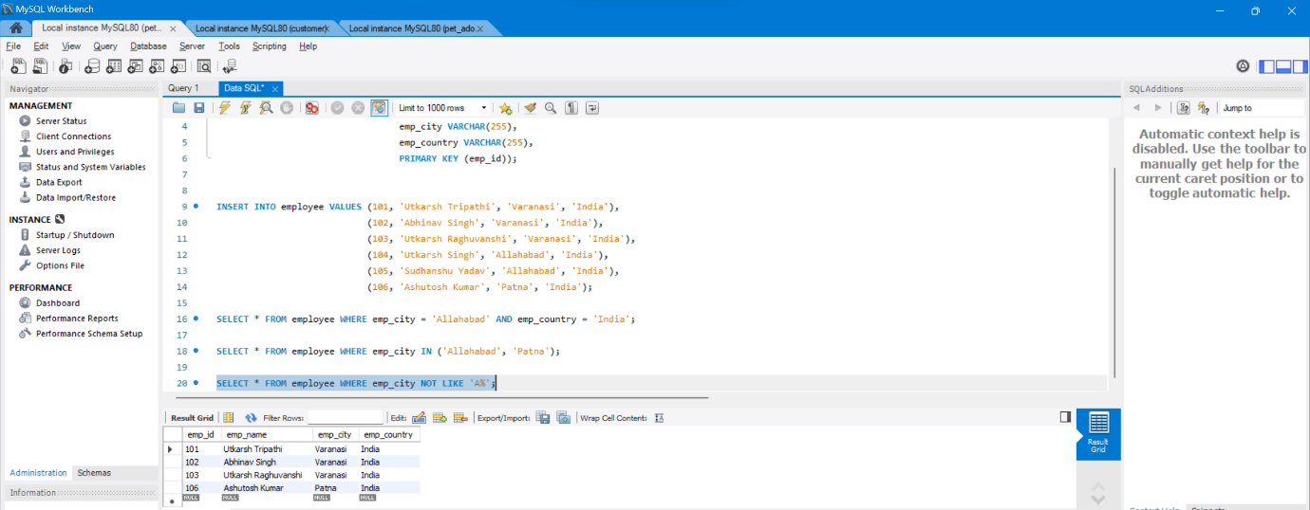

## **OR Operator**

### **Query**

SELECT * FROM employee WHERE emp_city = 'Varanasi' AND emp_country = 'India';

### **Output**

### 

## **LIKE Operator**

### **Query**

SELECT * FROM employee WHERE emp_city LIKE 'P%';

### **Output**

### 

## **BETWEEN Operator**

### **Query**

SELECT * FROM employee WHERE emp_id BETWEEN 101 AND 104;

### **Output**

### 

*output*

## **ANY Operator**

### **Query**

SELECT * FROM employee WHERE emp_id = ANY

(SELECT emp_id FROM employee WHERE emp_city = 'Varanasi');

### **Output**

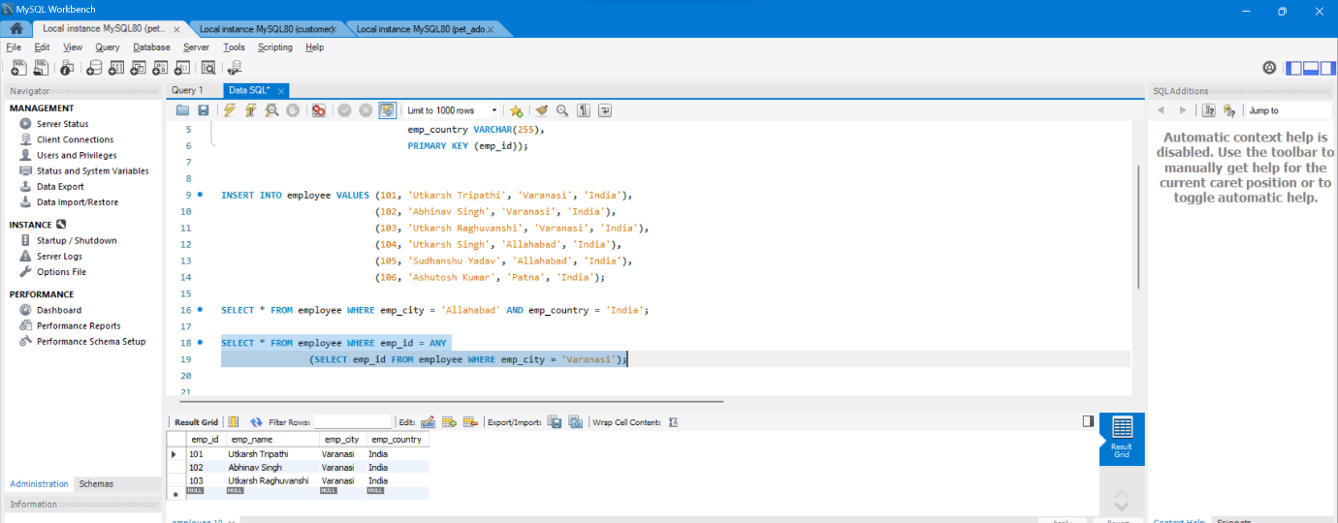

## **EXISTS Operator**

### **Query**

SELECT emp_name FROM employee WHERE EXISTS

(SELECT emp_id FROM employee WHERE emp_city = 'Patna');

### **Output**

### 

## **SOME Operator**

### Query

SELECT * FROM employee WHERE emp_id < SOME

(SELECT emp_id FROM employee WHERE emp_city = 'Patna');

### **Output**

### 

**JOINS**

**SQL | Join (Inner, Left, Right and Full Joins)**

**Student**

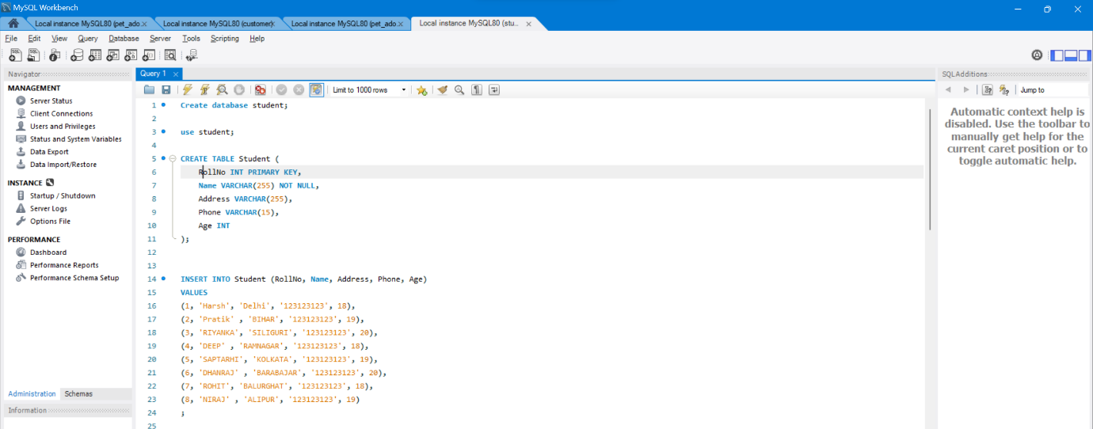

**StudentCourse**

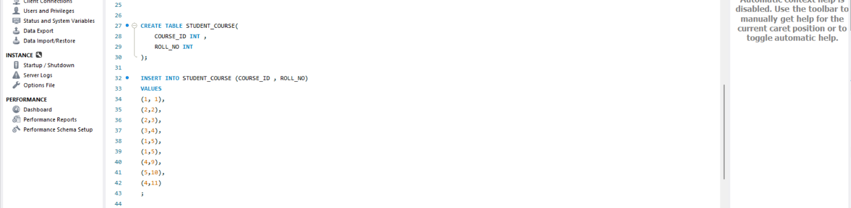

The simplest Join is INNER JOIN.

**A. INNER JOIN**

**Syntax**:

SELECT table1.column1,table1.column2,table2.column1,....  
FROM table1   
INNER JOIN table2  
ON table1.matching_column = table2.matching_column;

SELECT Student.COURSE_ID, Student.NAME, Student.AGE FROM Student  
INNER JOIN StudentCourse  
ON Student.ROLL_NO = StudentCourse.ROLL_NO;

**Output**:

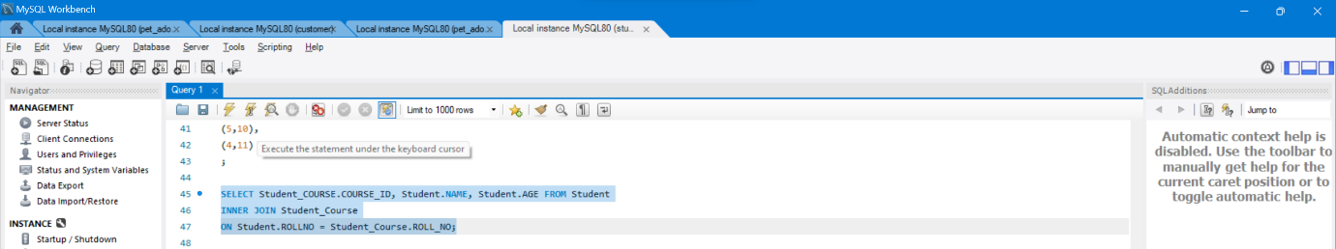

**B. LEFT JOIN**

**Syntax:**

SELECT table1.column1,table1.column2,table2.column1,....  
FROM table1   
LEFT JOIN table2  
ON table1.matching_column = table2.matching_column;

**Output**:

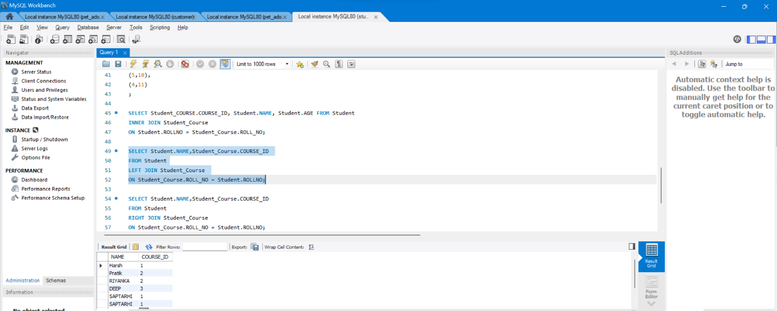

**C. RIGHT JOIN**

**Syntax:**

SELECT table1.column1,table1.column2,table2.column1,....  
FROM table1   
RIGHT JOIN table2  
ON table1.matching_column = table2.matching_column;  
  
**Output:**

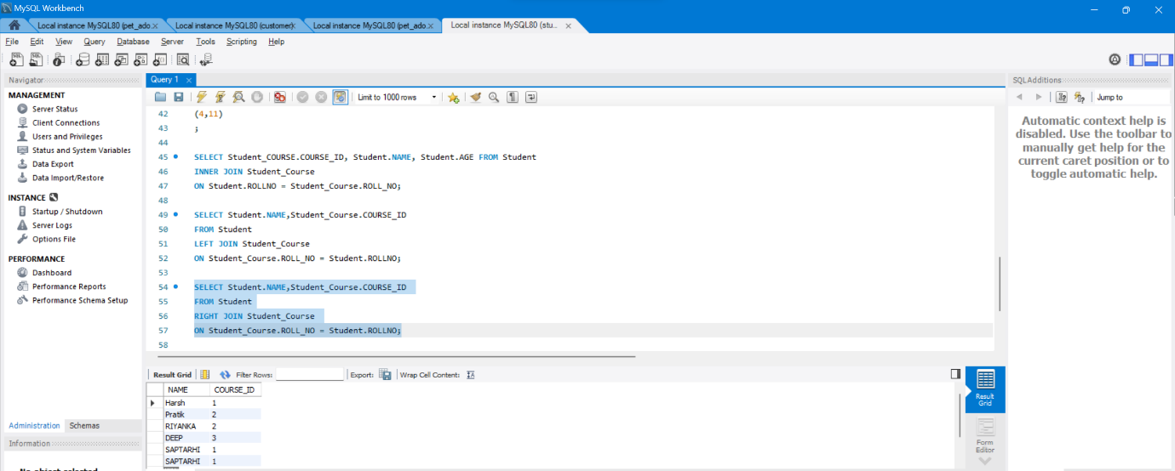

**D. FULL JOIN**

**Syntax:**

SELECT table1.column1,table1.column2,table2.column1,....  
FROM table1   
FULL JOIN table2  
ON table1.matching_column = table2.matching_column;

**Output:**

